To: Members of the Committee for Mathematics Achievement

From: Jim Justice, Director of Coaching
Laura Plante, Assistant Director of Coaching

Coach Demographics

 | Freshmen | Sophomore | Totals
Elementary | 21 | 17 | 38
Middle | 5 | 5 | 10
High | 12 | 9 | 21
Mid/High | 1 | 2 | 3
Elem/Mid/High | 0 | 1 | 1
Totals | 39 | 34 | 73

Follow-Up Training #1
The first follow-up training at EKU occurred on Sept. 17-19 and at WKU on Sept. 24-26.

Freshman Coaches: Days 3 and 4 of the Cognitive CoachingSM Foundation Seminar which reviewed Days 1 and 2 before discussing the Reflecting Conversation Map, Elements of Invitational Questions, and the 5 types of Feedback.

Sophomore Coaches: Day 1 of Edvantia: QUILT training (QUILT stands for “Questioning and Understanding to Improve Learning and Thinking). Also, Cognitive CoachingSM Proficiency Module which focused on the 5 traits of Craftsmanship, refining paraphrasing and questioning skills, and the 6 Domains of Inquiry.

RC Training
At the WKU Follow-up training, Toni Prickett and Carol Simoneau, our Cognitive CoachingSM trainers, offered to provide a day of training for the RCs to target their needs (metacoaching and online staff development). To show their support of Kentucky’s effort to ensure our mathematics coaches are well-trained, they offered to donate their time and expertise if we agreed to pay just their expenses. This day of training is scheduled for December 14th, 2007, at KCM. All RCs have been contacted and all have responded that they will be in attendance.

Centra Book Study
The first book study has begun in our Centra meetings. We are currently studying Formative Assessment Strategies for Every Classroom, an ASCD Action Tool. The discussion of this book began last year, but was cut very short due to CATS testing and other end-of-year tasks. Therefore, we are taking a more intensive look at it and encouraging coaches to not only experiment with the formative assessment instruments within the book but also to encourage their coachees to experiment as well.

Coaching Logs
We have begun the process of collecting more detailed data about coaching interactions. In October, coaches provided data about their coachees. Beginning this month, interaction summaries are being entered into Coaching Database. Sample forms for coachee profiles (Attachment A) and interaction summaries (Attachment B) are provided.

Coaching Website/Database Enhancements
Our tech coordinator, Bill Nostheide, has worked very diligently to enhance the coaching database. The database now includes:
- Secure login for RCs which connects them with documents and other resources. Another main function of this site is to provide a place for RCs to summarize visits with coaches. RCs enter the length of a visit, activities observed, topics discussed, and concerns. A screenshot of this page is provided (Attachment C).
- Secure login for Coaches which connect them with KCM documents, journal articles about coaching, activities and documents coaches want to share with other coaches, and a variety of other resources. This will also serve as the site they visit to log coaching interactions. A screenshot of this page is provided (Attachment D).
- Information about the use of the coaching database is being collected. This information includes the number of times a coach or RC has logged in and the date of the last login.

2008-2009 Training Schedule Proposal
The proposed Training Schedule for next year is attached (Attachment E). The only major change is that we offer training opportunities for our “Senior” coaches. Follow-up trainings for senior coaches include 4 ½ days of CCSM Proficiency Modules. We also ask that the CMA consider making it financially possible for senior coaches to attend the 8 days of CCSM Foundation seminar again to allow them to begin the process of becoming an Agency Trainer, which would build capacity and allow these coaches to provide the CCSM training for KCM’s new coaches. An additional RC training day should be added to the schedule at some point during the year.

KCTM Conference
The KCTM/T³ conference in Lexington on October 19-20 was a huge success. The following Coaches and Regional Coordinators presented during the conference: Cindy Aossey, Nancy Applegate, Patty Boyd, Nicole Brock, Patty Dermody, Keith Embry, Jeani Gollihue, Susan Gordon, Ronda Hunter, Denise Justice, Chris Lowber, Jim Moore, Penny Roberts, Jean Thornton, Renee Watkins, Leigh Ann Wells, Linda West, Patti Westphal, and LaDonna Woods. Jim Justice and Laura Plante gave a presentation about the Coaching Program to a room of about 20 educators. The content of the presentation related to the rationale for coaching and program specifics such as training, funding, requirements, and the role of the coach. In this presentation, eight sophomore coaches answered questions from participants and shared their experience.
Attachment A – Coachee Profiles

Coachee # | First Name | Last Name | # Years Teaching Experience | # Years of Experience in Your Building | Approximate # of Students They Teach | Teaching Profile (e.g. number of math classes taught; Elem: grade level; MS & HS: subjects taught, etc.) [NOTE: don't worry about space, just give complete description, please]
Coach
1
2
3
4
5
6
7
8
9
10

Attachment B – Interaction Summary Information Collected

Date of Interaction:

Coach:
Coachee #:

Amount of Time:

Level: Formal or Informal

Cognitive Coaching conversation: (check all that apply)
Planning
Reflecting
Problem Resolving

Other Types of Interaction (check all that apply)
Consulting
Collaborating
Observation of Class
With data collection
With no data collection
Gathering/Sharing Resources
Sharing of Data
Collected by Coach
Not collected by Coach
Facilitate Group Discussion
Leading PD
Co-Teaching
Model Teaching
Other: text box

Comments:

Attachment C – RC Login Page

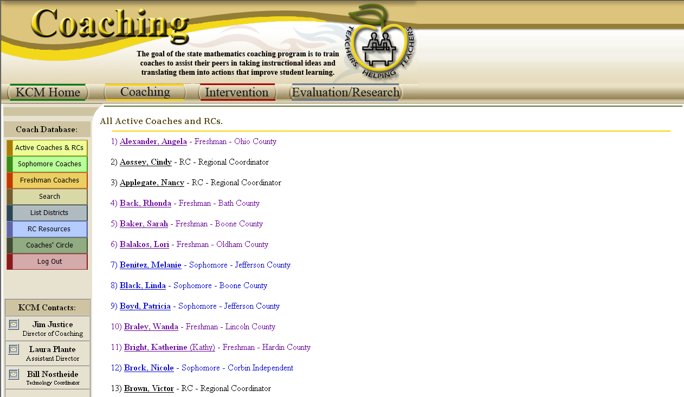

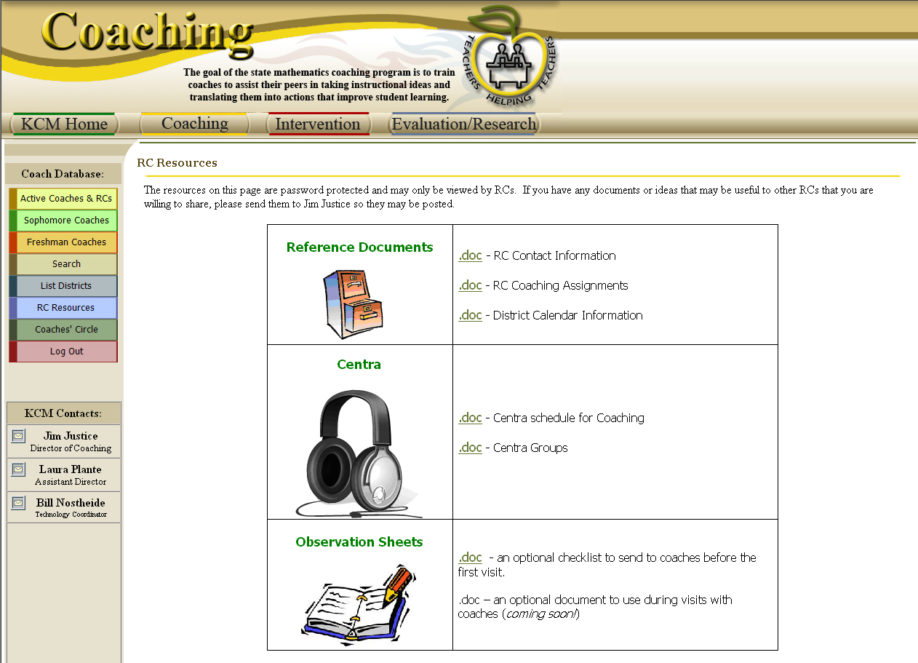

Attachment D – Coach Login Page

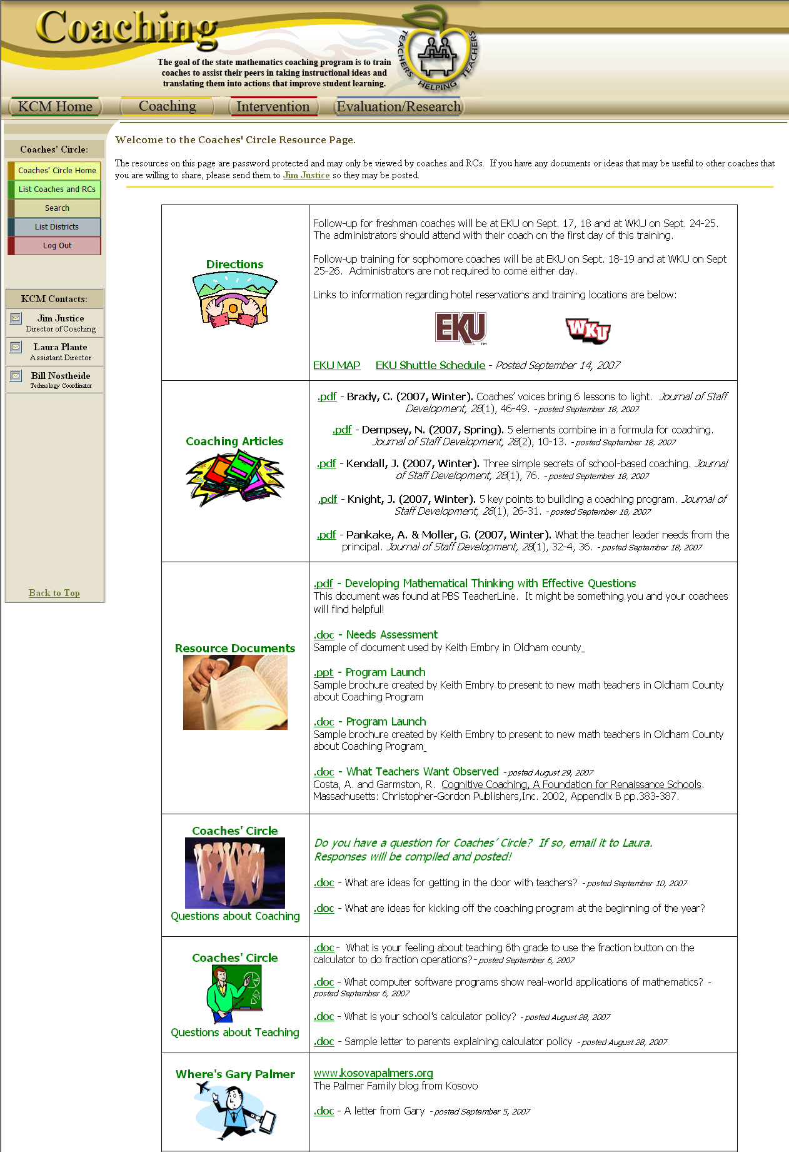

Attachment E – Training Schedule Proposal 2008-2009

JUNE – JULY 2008
Monday | Tuesday | Wednesday | Thursday | Friday
2 | 3 | 4 | 5 | 6
9 | 10 | 11 | 12 | 13
16 SITE #1 | 17 SITE #1 | 18 SITE #1 | 19 SITE #1 | 20 SITE #1
Freshman  CC – Foundations Day 1  Sophomore  Coaching Classroom Management | Freshman  CC – Foundations Day 2  Sophomore  Coaching Classroom Management | Freshman  Coach-Admin Planning  Sophomore  CC – Proficiency Mod. #1 | Sophomore  CC – Proficiency Mod. #2 | Sophomore  Coach-Admin Planning
23 SITE #2 | 24 SITE #2 | 25 SITE #2 | 26 SITE #2 | 27 SITE #2
Freshman  CC – Foundations Day 1  Sophomore  Coaching Classroom Management | Freshman  CC – Foundations Day 2  Sophomore  Coaching Classroom Management | Freshman  Coach-Admin Planning  Sophomore  CC – Proficiency Mod. #1 | Sophomore  CC – Proficiency Mod. #2 | Sophomore  Coach-Admin Planning
30 | 1 | 2 | 3 | 4
7 NKU | 8 NKU | 9 NKU | 10 NKU | 11 NKU
Freshman  CC – Foundations Day 1  Sophomore  Coaching Classroom Management | Freshman  CC – Foundations Day 2  Sophomore  Coaching Classroom Management | Freshman  Coach-Admin Planning  Sophomore  CC – Proficiency Mod. #1 | Sophomore  CC – Proficiency Mod. #2 | Sophomore  Coach-Admin Planning
14 NKU | 15 NKU | 16 NKU | 17 NKU | 18 NKU
Freshman  Math Solutions | Freshman  Math Solutions | Freshman  Math Solutions | Freshman  Math Solutions | Freshman  Math Solutions
21 | 22 | 23 | 24 | 25

Bob Pervine and Edna Schack have been asked to consider hosting 2008-2009 Coaching training. They both have expressed interest in hosting training. If this partnership develops, then Site #1 would become Morehead State and Site #2 would become Murray State.
Attachment E – Training Schedule Proposal 2008-2009 (CONTINUED)

Follow-up 1 (Late September)

Monday | Tuesday | Wednesday | Thursday | Friday
Freshman – Site #1  CC – Foundations Day 3 (with Admin) | Freshman – Site #1  CC – Foundations Day 4  Sophomore – Site #1  Edvantia – Questioning | Sophomore – NKU  CC – Proficiency Mod. #1 | Freshman – NKU  CC – Foundations Day 3 (with Admin)  Sophomore – NKU  Edvantia – Questioning | Freshman – NKU  CC – Foundations Day 4
Senior– NKU  CC – Proficiency Mod. #4 | Senior– NKU  CC – Proficiency Mod. #5 (½ day) | Sophomore – Site #2  CC – Proficiency Mod. #1 | Freshman – Site #2  CC – Foundations Day 3 (with Admin)  Sophomore – Site #2  Edvantia – Questioning | Freshman – Site #2  CC – Foundations Day 4

Follow-up 2 (Early December)

Monday | Tuesday | Wednesday | Thursday | Friday
Freshman – Site #1  CC – Foundations Day 5 | Freshman – Site #1  CC – Foundations Day 6  Sophomore – Site #1  Edvantia – Questioning | Sophomore – NKU  CC – Proficiency Mod. #2 | Freshman – NKU  CC – Foundations Day 5  Sophomore – NKU  Edvantia – Questioning | Freshman – NKU  CC – Foundations Day 6
Senior– NKU  CC – Proficiency Mod. #6 | Senior– NKU  CC – Proficiency Mod. #7 (½ day) | Sophomore – Site #2  CC – Proficiency Mod. #2 | Freshman – Site #2  CC – Foundations Day 5  Sophomore – Site #2  Edvantia – Questioning | Freshman – Site #2  CC – Foundations Day 6

Follow-up 3 (Late January)

Monday | Tuesday | Wednesday | Thursday | Friday
Freshman – Site #1  CC – Foundations Day 7 | Freshman – Site #1  CC – Foundations Day 8  Sophomore – Site #1  Edvantia – Questioning | Sophomore – NKU  CC – Proficiency Mod. #3 | Freshman – NKU  CC – Foundations Day 7  Sophomore – NKU  Edvantia – Questioning | Freshman – NKU  CC – Foundations Day 8
Senior– NKU  CC – Proficiency Mod. #8 | Senior– NKU  CC – Proficiency Mod. #9 (½ day) | Sophomore – Site #2  CC – Proficiency Mod. #3 | Freshman – Site #2  CC – Foundations Day 7  Sophomore – Site #2  Edvantia – Questioning | Freshman – Site #2  CC – Foundations Day 8

