TO: The Committee for Mathematics Achievement
FROM: Alice Gabbard, Director of Diagnostic Intervention
Jonathan Thomas, Assistant Director of Diagnostic Intervention
RE: Diagnostic Intervention Programs
DATE: June 13, 2008

2008/2009 Mathematics Intervention Teacher (MIT) Population

MIT Count as of June 2008
 | Round One  (MAF 06) | Round Two  (MAF 07) | Round Three  (MAF 08) | Totals
Math Recovery Only | 6 | 6 | 4 | 16
Math Recovery & NW | 10 | 7 | 3 | 20
NW & Add+Vantage* | 16 | 4 | 21 | 41
Number Worlds (NW) Only** | 13 | 26 |  | 39
Total MITs | 45 | 43 | 28 | 116
Total Mathematics Achievement Fund (MAF) grants | 45 | 41 | 27 | 113
MITs entering third year *** | 31 |  |  | 31
MITs entering second year | 8 | 43 |  | 51
MITs entering first year | 6 |  | 27 | 33

*Experience, data and MIT input indicate that the best Number Worlds training supplement is possibly Add+Vantage, which will grow MITs’ understanding of student numeracy development and skill in using dynamic diagnostic assessment to guide differentiated instruction.

**With supplemental training from the KCM, Math Solutions, and/or Catherine Fosnot

***81% (21/31) have chosen to attend Math Recovery or Add+Vantage training

MIT Program Opinions

The graphs below reflect the mean MIT ratings of the strengths/weaknesses of Math Recovery and/or Number Worlds in the following categories:

1) Developmental Appropriateness
2) Lessons/Activities
3) Assessments
4) Technology/Software
5) Materials/Manipulatives
6) Inquiry Skills

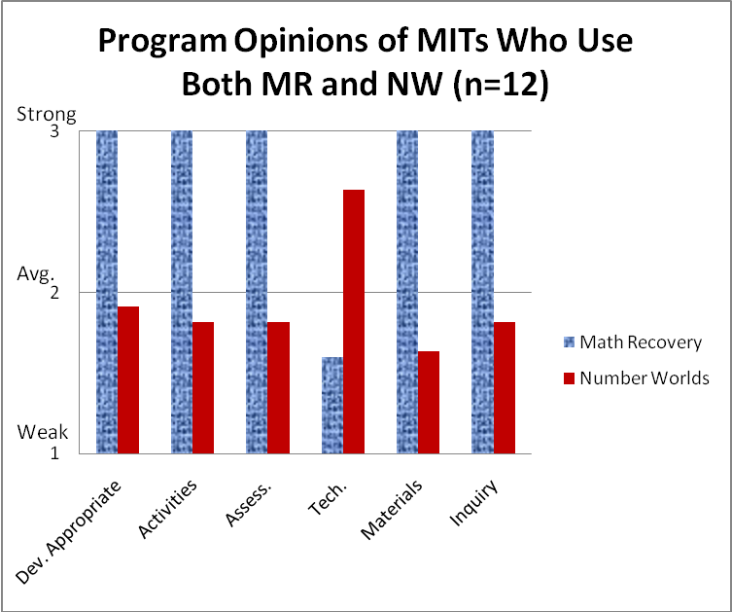
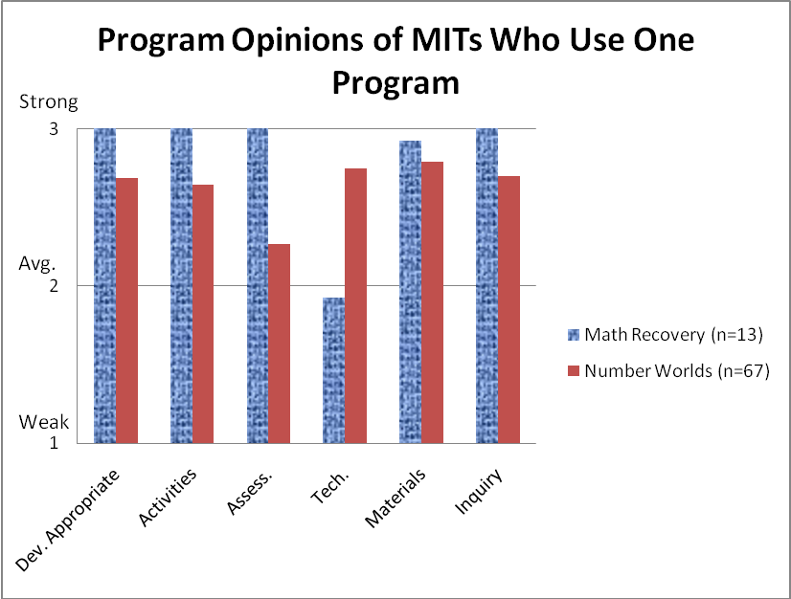

Mathematics Achievement Fund

$6,900,000 was allocated for the Mathematics Achievement Fund for each year of the past (06—08) biennium and for each year during the coming (08—10) biennium. Selected schools receive $70,000 for the first year and $60,000 for the second year. Third year MAF grants have also been extended to the initial 45 recipients for $60,000 in the 2008/2009 school year. The number and amount of 2009/2010 MAF grants will be determined by the KDE.

MAF Grants Funded for 2006 | $3,150,000
MAF Grants Funded for 2007 | $2,700,000 + $2,870,000 = $5,570,000
MAF Grants Funded for 2008 | $2,700,000 + $2,460,000 + $1,890,000 = $7,050,000

New Free Printable Math Tools Created by the KCM

The KCM has uploaded on the KCM Resources/Math Tools webpage free printable classroom-sized five frame and ten frame flash cards with dots which may be used to build quantitative reasoning and automaticity with basic facts.

Kentucky System of Intervention (based on the federal Response to Intervention Guidelines)

The Kentucky System of Intervention will likely be released by the KDE in June 2008 and is expected to consist of a framework that will allow schools flexibility to determine the grade levels, subjects, pacing, and instruments that will be used to serve the general population with progress monitoring and tiered, research-based intervention before any student is referred for special education services.

National Board Certification

In May 2008 the KCM requested that the CMA recommend to the National Board for Professional Teaching Standards (NBPTS) the establishment of an opportunity for certification of elementary mathematics specialists, which would provide development, support and pay bonuses for much-needed full-time elementary mathematics teachers/interventionists. In response to the CMA’s request for more information, below is an elaborated discussion of the need for expanding the NBPTS certification options to include full-time elementary mathematics specialists.

Purpose of National Boards

The National Board for Professional Teaching Standards (NBPTS) was formed in 1987 to increase the quality of teaching and learning through the establishment of rigorous and voluntary certification programs which incorporate research-supported educational practices and allows participating teacher to earn financial rewards and the status of Nationally Board Certified Teacher (NBCT). Presently, the NBPTS offers discipline-specific certificates at multiple levels including mathematics for teachers of adolescents and young adults (NBPTS, 2008), but none for the critical area of early childhood mathematics. The purpose of this document is to clearly delineate the necessity for the establishment of a certification option that supports the work of full-time elementary mathematics teachers/interventionists to develop skill in early mathematical teaching and learning.
Complexity of Teaching Early Childhood Mathematics

Investigations by educational researchers over the past two decades have revealed that the teaching and learning of early mathematical concepts is a profoundly complex activity. Since the late eighties many studies have shed light on the nature in which children come to understand mathematical ideas related to counting (Steffe, 1992), quantitative structuring (Fosnot & Dolk, 2001), arithmetical operations (Fuson, 1992), and place value (Kamii, 1989). A child’s current mathematical understanding may now be diagnosed with precision which typically leads to far more effective instructional experiences. Furthermore, activities historically regarded as trivial (i.e. finger patterns, subitizing) now serve as powerful levers in this process. It is clear that elementary teachers must develop a deep understanding of sophisticated mathematical concepts as well as effective, supporting pedagogical trajectories, and an increasing number of teachers are working toward gaining such expertise in early mathematics instruction (KCM, 2008).
National Board Certification for Improved Teaching

As the premier symbol of professional excellence, NBCTs receive significant recognition for their prodigious expertise; however, much more is to be gained from this process than simply acknowledgement and regard for the individual. Educational stakeholders can be assured that NBCTs “possess pedagogical content knowledge that is more flexibly and innovatively employed; they are more able to improvise and alter instruction in response to the contextual features of the classroom. . . provide more developmentally learning tasks. . .anticipate and plan for difficulties students are likely to encounter with new concepts” (Bond et al., 2000). Furthermore, the experience of certification has the power to “fundamentally change the way (teachers) think about and approach teaching”; it is important to note that such a transformation occurred even with those that attempted, but did not gain certification. (Bond et al., 2000).
Impact on Students

There has been much study on the effectiveness of NBCTs with respect to student achievement, although researcher opinions differ regarding the appropriateness of various statistical techniques. Using certain types of regression analysis (i.e. Ordinary Least Squares), several studies have found that “students of NBCTs experienced year-end testing improvements that averaged 7 percent to 15 percent more than peers whose teachers were not NBCTs” (Goldhaber & Anthony, 2004). Vandevoort et al. (2004) “found that students of NBCTs outperformed students of non-NBCTs on the Stanford-9 achievement test, with learning gains equivalent on average to spending more than an extra month in school each year.” Some researchers argue that a hierarchical linear model of regression analysis is better suited for such study (Sanders et al., 2005; Stronge et al., 2007).

When such modeling is employed, NBCT impact on student achievement is much more nuanced; however, these authors still reported significant effect sizes related to NBCT impact in the area of elementary mathematics (grades 4-6). Although impact on the early elementary grades has yet to be examined, such results strongly suggest the potential for translation of NBCT expertise to the mathematical learning of young children and the need for specialist certification in this area.
Added National Board Certification for Teachers of Early Mathematics

We respectfully submit that the current NBPTS certification structure does not provide an adequate mechanism to recognize the profound expertise of teachers in the area of early mathematics. As the need becomes more apparent and the interest for improving early mathematics teaching grows, so does the need for a specific related certification field. In Kentucky, there were 251 active NBCTs as of 2007. Given the significant population of early mathematics specialists throughout the Commonwealth (KCM, 2008), it is probable that this number would increase with the creation of an early mathematics certification track; furthermore, it is reasonable to believe that such need and interest may be a nationwide phenomenon. Again, as we recognize the complexity of the domain and the potential impact that certification would have on both teachers and students; provision of National Board Certification in early mathematics would likely prove highly valuable for the future of our nation.
References

Bond, L., T. Smith, W. Baker, and J. Hattie. 2000. The Certification System of the National Board for Professional Teaching Standards: A Construct and Consequential Validity Study. University of North Carolina at Greensboro, Center for Educational Research and Evaluation.
Fosnot, C., & Dolk, M. (2001). Young mathematicians at work: Constructing number sense, addition and subtraction. Portsmouth: Heinemann.
Fuson, K. (1992). Research on whole number addition and subtraction. In D. Grouws (Ed.), Handbook of research on mathematics teaching and learning (pp. 243–275). New York: Macmillan.
Goldhaber, D., and Anthony, E. (March 8, 2004). Can Teacher Quality Be Effectively Assessed. The Urban Institute. Available online at http://www.urban.org/UpLoadedPDF/410958_NBPTSOutcomes.pdf.
Kamii, C. (1989). Young children continue to reinvent arithmetic – 2nd grade: Implications of Piaget’s theory. New York: Teachers College Press.
KCM. (2008). Intervention, last accessed on June 5, 2008, from: http://www.kymath.org/intervention/intervention.asp
NBPTS. (2004). Fields of Certification, last accessed on June 5, 2008, from: http://nbpts.org/become_a_candidate/available_certificates1/fields_of_certification
Sanders, W. L., Ashton, J.J., Wright, S.P. (2005, March 7). Comparisons of the effects of NBPTS certified teachers with others teachers on the rate of student academic progress. Retrieved June 8, 2006, from National Board for Professional Teaching Standards Web site: http://www.nbpts.org/pdf/sas_final_report.pdf
Steffe, L. (1992). Learning stages in the construction of the number sequence. In J. Bideaud, C. Meljac, & J. Fischer (Eds.), Pathways to number: Children’s developing numerical abilities (pp. 83–88). Hillsdale: Lawrence Erlbaum.
Stronge, J. H., Ward, T. J., Tucker, P. D., Hindman, J. L., McColsky, W., & Howard, B. (2007). National Board Certified Teachers and Non-National Board Certified Teachers: Is There a Difference in Teacher Effectiveness and Student Achievement? Journal of Personnel Evaluation in Education, 20(3-4), 185 - 210.
Vandevoort, L. G., Amrein-Beardsley, A., and Berliner, D. C. (September 8, 2004). National Board Certified Teachers and Their Students’ Achievement. Education Policy Analysis Archives, 12 (46). Available online at http://epaa.asu.edu/epaa/v12n46/v12n46.pdf.

