TO: The Committee for Mathematics Achievement
FROM: Alice Gabbard, Director of Diagnostic Intervention
Jonathan Thomas, Assistant Director of Diagnostic Intervention
RE: Diagnostic Intervention Programs
DATE: May 9, 2008

National Board Certification
http://www.nbpts.org/

Whereas many Kentucky mathematics intervention teachers are highly motivated to potentially achieve or renew National Board Certification, there is no option for full-time elementary mathematics specialists. This is unfortunate for Kentucky’s ambitious initiative to improve mathematics education, because developing elementary mathematics specialists is one of our greatest needs. According to Deborah Ball, as quoted in the 2007 Kentucky EPSB report written by Terry Hibpshman “A Brief Review of the Preparation of Kentucky Mathematics and Science Teachers,”

“… teaching mathematics to students in the earliest grades is a demanding process that requires surprisingly high levels of mathematical knowledge. Elementary teachers must impart mathematical knowledge to children who may have difficulty understanding the content regardless of how it is delivered, and teachers need to have sufficiently broad understanding of the content to be able to represent it in multiple ways.”

Ball, D. L. (1990). The mathematical understanding that prospective teachers bring to teacher education. The Elementary School Journal, 90, 449-466

The KCM is conducting a census of recent Kentucky graduates earning a bachelor’s degree in elementary education, which may support the hypothesis that very few elementary teachers have an undergraduate emphasis in mathematics, giving further evidence of the need for systemic change to provide mechanisms for growing elementary teachers’ mathematical content knowledge.

The KCM respectfully requests that the CMA consider passing a formal motion for submission to the National Board for Professional Teaching Standards and to other national policy makers suggesting that a certification option be offered for elementary mathematics specialists.

Articulated Training and Support Objectives
As an extension of the mission statement, “The goal of the state diagnostic intervention program is to expand the capacity of teachers to assess a child’s current status and adjust instruction accordingly,” we have further detailed the objectives of training and support for MITs.
The Kentucky Center for Mathematics provides mathematics intervention teachers with high quality training and sustained support for:
- Understanding the complexities of mathematical concepts from the earliest grade levels.
- Awareness of and ability to support the natural progression of mathematical development.
- Ability to pinpoint student need/readiness for learning mathematics using diagnostic/formative assessments that show what a child can do (an asset model) and what instruction is needed for advancing his/her thinking.
- Building a strong mathematical foundation and flexible advanced mental computation skills by facilitating students’ opportunities for deep thinking, both silently and aloud, in order to make sense of mathematics.
Defining Diagnostic Assessment

Realizing that “diagnostic assessment” is the critical component for determining student need to guide teaching intervention practice and that the term is frequently misused as a synonym for pre-testing to measure deficits, the KCM/Intervention webpage now includes a discussion of diagnostic assessment as an asset model that “creates a rich portrait of a child’s present understanding and strategies as well as avenues for future development:” Towards Dynamic Diagnostic Assessment by Jonathan Thomas, Kentucky Center for Mathematics. http://kymath.org/intervention/doc/2008/Dynamic%20Assessment.pdf

MIT Leadership Development

As approximately 32 of the original 45 MITs enter their third year of service (13 who have Math Recovery Specialist Certification and 17 who have Number Worlds experience only), they are expected to choose a training program for further developing their leadership skills in strengthening collegial collaboration and establishing professional learning communities while continuing to teach. The following training options have been suggested: Cognitive Coaching Foundations Course, Math Recovery Leader Training, National Council of Supervisors of Mathematics Leadership Academy, and/or an MIT PRIME Leader Group.

Third Round Mathematics Achievement Fund (MAF) Grants

27 MAF grants of $70,000 were awarded (from a pool of 230 applications) for the third round to begin July 1, 2008. 86 round 1 and round 2 MAF grants of $60,000 will also be continued, bringing the total to 113 MAF schools for the 2008/2009 school year, as shown on the map below. Of the 27 new MAF schools, 20 chose Number Worlds, 3 chose Math Recovery and 4 chose both programs. At least 14 of the Number Worlds MITs from MAF rounds 1 and 2 plan to attend Add+Vantage MR or Math Recovery Specialist Training in the coming months.

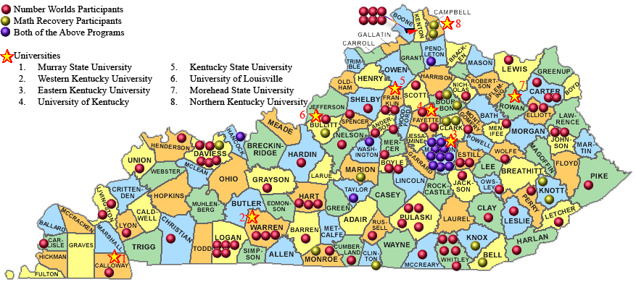

Data Collection

MITs are assessing all current and previous intervention and comparison students using Terra Nova. Since this is the last round of free testing provided by SRA/McGraw Hill, the KCM will be paying for tests and scoring henceforth. Variables for analysis will include:

- Grade level
- Program (Math Recovery one-on-one, Math Recovery group, Number Worlds, Both)
- Teacher intervention experience (first year, second year)
- Student status (current intervention, previous intervention, comparison)

2008 National Math Recovery Conference in Covington,
April 16—18, 2008

The National Math Recovery Conference had higher attendance than expected of 200+ people and gave Kentucky a chance to shine as the only state to fund full-time primary mathematics intervention teachers, leading the way for systemic change. Senator Kelly spoke to an audience via phone during a panel discussion presented also by NKU Professor Gina Foletta and Mike Hammons, president of Vision 2015. Kentucky attendees were enthusiastic about their rich experiences, including many opportunities for discussions with world-famous researchers and authors.
Training & Support Details

All MITs | • One-hour online meetings, weekly for first year & at least monthly for experienced MITs.  • Monthly posting on the KCM Forum  • Kentucky Council of Teachers of Mathematics (KCTM) Annual Conference, Louisville, October 11, 2008  • Kentucky Teaching and Learning Conference (KTLC), Louisville, March 2009, including MIT pre-conference meeting on Wednesday, 10:00 to 3:00  • Optional: US Math Recovery Council (USMRC) membership (required for Math Recovery Specialist Certification) and conference attendance  • Optional: National Council of Teachers of Mathematics (NCTM) membership and conference attendance.
 | Beginning MITs | 2nd Year MITs | 3rd Year MITs
Number Worlds | • 2 days of KCM Connections, July 2008 (UK, Whitley, Livingston)  • 3 days of Math Solutions, Northern Kentucky, July 22-24, 2008  • 3 days of Math Solutions, Northern Kentucky, November 2008  • 3 days of Landscape of Intervention, Northern Kentucky, Early February 2008  • Monthly visits from a Regional Coordinator  • Optional: Spend a day with an experience Number Worlds MIT, spring 2008 | • 3 days Advanced Landscape of Intervention, June 10-13 2008  • 3 three-hour regional collegial team meetings  • Assist/co-lead/lead a presentation at KTLC or KCTM  • Optional:  Add+Vantage Teacher Course 1 | • 3 days of release time to visit other MITs w/written summary  • 3 three-hour regional collegial team meetings  • Assist/co-lead/lead a presentation at KTLC or KCTM  • Leadership development
Math Recovery | • 1 day of KCM Connections, July 2008 (UK, Whitley, Livingston)  • 5 days of Specialist Training, Northern Kentucky, July 14-18, 2008  • 3 days of Specialist Training, Northern Kentucky, September 2008  • 2 days of Specialist Training, Northern Kentucky, November 2008  • 4 three-hour collegial team video review meetings  • 3 on-site coaching sessions  • Visits from a Regional Coordinator  • Optional: Spend a day with an experienced Math Recovery MIT, spring 2008 | • 3 days Advanced Specialist Training, Nashville, June 22-24, 2008  • 3 three-hour collegial team video review meetings  • Assist/co-lead/lead a presentation at KTLC or KCTM  • Optional: Add+Vantage MR Champion Training and SNAP Facilitator Training, Nashville, June 24-28, 2008 | • 3 days of release time to visit other MITs w/written summary  • 3 three-hour collegial team video review meetings  • Assist/co-lead/lead a presentation at KTLC or KCTM  • Leadership development

Primary Diagnostic Assessment Overview

KCM will host a Primary Diagnostic Assessment Overview Session for up to 30 MITs and Math Leaders, May 29, 2008 at Campbellsville Elementary in Taylor County, for the purpose of studying assessment programs that claim to be diagnostic, including:

- NWEA Measures of Academic Progress (MAP) for Primary Grades http://www.nwea.org/assessments/primary.asp
- Group Mathematics Achievement and Diagnostic Evaluation (GMADE)
http://ags.pearsonassessments.com/group.asp?nGroupInfoID=a25010
- Key Math 3
http://ags.pearsonassessments.com/Group.asp?nGroupInfoID=aKeymath3
- Wireless Generation mClass-MATH
http://www.wirelessgeneration.com/math-assessment.php
- Didax, Assessing Number Concepts
http://www.didax.com/amc/
- AIMS Web
http://www.aimsweb.com/
- ThinkLink/PAS
http://www.thinklinkassessment.com/corporate/

Resource Development

The KCM has continued to expand the online resource bank and has recently added web pages for Involving Families, Mathematics Education, and Standards. Kentucky mathematicians, mathematics teacher educators, and mathematics teachers are invited to contribute resources. The KCM has also created and uploaded many free printable “math tools” and a Spanish/English elementary math vocabulary translation guide.



