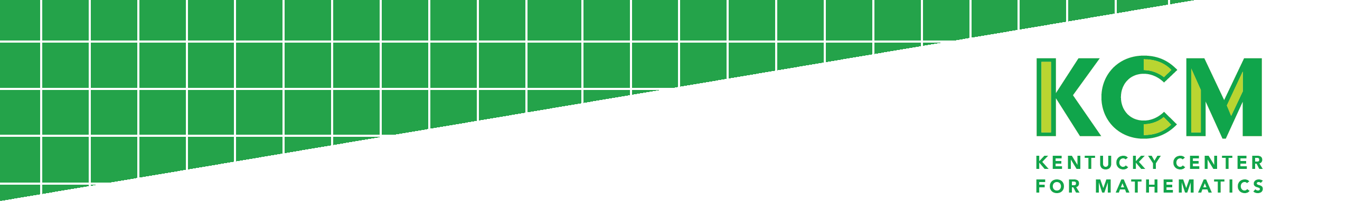
Introduction to Abacus

Abacus is the document and data upload center utilized by the Kentucky Center for Mathematics. This secure website will be used for you and your school to submit consent forms and upload schoolwide student assessment data.

Getting Started with Abacus

- Go to https://kcm.nku.edu/abacus/
- Click “Login”
- Set your password by clicking “Forgot your password? Reset it.”
- Sign in with your school email address and password.

Assignments in Abacus

All MAF classroom teachers and MITs have been given assignments in Abacus.

MIT Assignments for 2017-2018
- Complete the Participant Consent Form and upload to the appropriate Abacus assignment.
- Send Guardian/Parental Consent Forms home with your small-group / one-on-one intervention students.
  - Once the KCM has received your Infinite Campus data in October/November, you will be able to upload and attach the applicable student consent to the appropriate student.
  - All consent forms, including the Guardian/Parental Consent forms in multiple languages, can be found under the “Documents” section of the MAF Resources Webpage.
- Submit Fall Schoolwide Test Data per Abacus “Help” Instructions.
- Submit Spring Schoolwide Test Data per Abacus “Help” Instructions.

Classroom Teacher Assignments for 2017-2018
- Complete the Participant Consent Form and upload to the appropriate Abacus assignment.

Questions

Questions regarding Abacus can be sent to abacus@nku.edu.
