

Journey to Numeracy for All
MIT Professional Learning Framework

Table of Contents
September—Emergent counting
October—Perceptual counting
November—Structuring to five and ten
December—Figurative counting
January—Structuring to twenty
February—Tens and ones
March—Advanced addition and subtraction
April—Early multiplication and division

The goal of the state mathematics diagnostic intervention program is to expand the capacity of teachers to assess a child's current status and adjust instruction accordingly.
September—Emergent Counting
During Centra online meetings MITs will explore/use strategies and resources for teaching number words and numerals and for advancing students who are emergent counters, always keeping in mind that instruction must be targeted at each student’s readiness level. MITs will also discuss ways in which to facilitate students’ integration of the 3 aspects of number, including symbolic representation as well as quantitative reasoning and number words.
Resources –These suggestions are offered as flexible possibilities and should not be interpreted as required or exhaustive. Please select or supplement based on group need and availability of resources.

Blue Book→ (included with MR Specialist kit) Wright, Martland, Stafford. (2006). Early Numeracy; Assessment for teaching and intervention, 2nd Edition. Paul Chapman Publishing.
- Chapter 1: Children, Numeracy, and Mathematics Recovery
- Pages 53—56
- See various scenarios on pages 75—91
- Chapter 10: Linking the Assessment to Teaching

Bresser, Rusty and Holtzman, Caren. (2006). Minilessons for Math Practice, Grades K—2. Math Solutions Publications.
- Chapter 14: Guess My Number

Dacey, Linda and Eston, Rebeka. (2002). Show and Tell; Representing and Communicating Mathematical Ideas in K—2 Classrooms. Math Solutions Publications.
- Chapter 1: Show and Tell: An Overview
- Chapter 2: Talking About Numbers

Green Book→ (included with MR Specialist kit) Wright, Martland, Stafford, Stanger. (2007). Teaching Number; Advancing children’s skills and strategies, 2nd edition. Paul Chapman Publishing.
- Chapter 1: Advancing Children’s Strategies and Knowledge in Early Number
- Chapter 2: Individualized Teaching in Math Recovery (includes Guiding Principles of Teaching, Key Elements of Teaching, and Characteristics of Child Problem-Solving in Individualized Teaching)
- Chapter 5: Teaching the Emergent Child

Purple Book→ (included with Add+Vantage Course 1 kit) Wright, Stanger, Stafford, Martland. (2006). Teaching Number in the Classroom with 4—8 Year Olds. Paul Chapman Publishing.
- Chapter 3: Number Words and Numerals

Van de Walle, John A. and Lovin, Lou Ann. (2006). Teaching Student-Centered Mathematics: Grades K—3. Allyn & Bacon Publishing.
- Chapter 1: Foundations of student-centered instruction
- Chapter 2: Developing early number concepts and number sense

White Book→ van den Heuvel-Panhuizen, Marja, editor (2001). Children Learn Mathematics, A Learning-Teaching Trajectory with Intermediate Attainment Targets for Calculation with Whole Numbers in Primary School. Freudenthal Institute, Utrecht University & National Institute for Curriculum Development.
- Pages 25—30: Pre-school years; Emergent Numeracy and

Supplemental Unit→ Fosnot, Catherine Twomey (2007). Contexts in Learning: Investigating Number Sense, Addition, and Subtraction (K–3). Bunk Beds and Appleboxes—Early Number Sense. Heinemann.

++++++++++++++++++++++++++++++++++++++++++++++++++++++++++++++++++


Do math: Develop a base 5 system of counting with your own creation of unique symbols and words for each quantity, 0 to 4, and a rule that you must regroup whenever you get more than 4. Teach your group how to count and add using your numeration system.

The goal of the state mathematics diagnostic intervention program is to expand the capacity of teachers to assess a child's current status and adjust instruction accordingly.
October—Perceptual Counting
During Centra online meetings MITs will explore/use strategies and resources for advancing students through the perceptual counting stage, always keeping in mind that instruction must be targeted at each student’s readiness level. MITs will also discuss ways in which to facilitate students’ integration of the 3 aspects of number, including symbolic representation as well as quantitative reasoning and number words.
Resources –These suggestions are offered as flexible possibilities and should not be interpreted as required or exhaustive. Please select or supplement based on group need and availability of resources.

Blue Book→ (included with MR Specialist kit) Wright, Martland, Stafford. (2006). Early Numeracy; Assessment for teaching and intervention, 2nd Edition. Paul Chapman Publishing.
- Pages 56—60
- See various scenarios on pages 75—91
- Chapter 10: Linking the Assessment to Teaching

Bresser, Rusty and Holtzman, Caren. (2006). Minilessons for Math Practice, Grades K—2. Math Solutions Publications.
- Chapter 1: Addition and Subtraction Word Problems
- Chapter 4: Building the 1-100 Chart
- Chapter 8: Dots
- Chapter 19: More or Less? (with counters)
- Chapter 24: Race to 20

Dacey, Linda and Eston, Rebeka. (2002). Show and Tell; Representing and Communicating Mathematical Ideas in K—2 Classrooms. Math Solutions Publications.
- Chapter 3: Connecting Numbers, Stories, and Facts
- Chapter 4: Representing Numbers and Operations

Green Book→ (included with MR Specialist kit) Wright, Martland, Stafford, Stanger. (2007). Teaching Number; Advancing children’s skills and strategies, 2nd edition. Paul Chapman Publishing.
- Chapter 1: Advancing Children’s Strategies and Knowledge in Early Number
- Chapter 2: Individualized Teaching in Math Recovery (includes Guiding Principles of Teaching, Key Elements of Teaching, and Characteristics of Child Problem-Solving in Individualized Teaching)
- Chapter 6: Teaching the Perceptual Child

Purple Book→ (included with Add+Vantage Course 1 kit) Wright, Stanger, Stafford, Martland. (2006). Teaching Number in the Classroom with 4—8 Year Olds. Paul Chapman Publishing.
- Chapter 4: Early Counting and Addition
Van de Walle, John A. and Lovin, Lou Ann. (2006). Teaching Student-Centered Mathematics: Grades K—3. Allyn & Bacon Publishing.
- Chapter 3: Developing meaning for the operations and solving story problems

White Book→ van den Heuvel-Panhuizen, Marja, editor (2001). Children Learn Mathematics, A Learning-Teaching Trajectory with Intermediate Attainment Targets for Calculation with Whole Numbers in Primary School. Freudenthal Institute, Utrecht University & National Institute for Curriculum Development.
- Pages 31—42: Kindergarten 1 and 2; Growing Number Sense

Supplemental Unit→ Fosnot, Catherine Twomey (2007). Contexts in Learning: Investigating Number Sense, Addition, and Subtraction (K–3). Beads and Shoes, Making Twos—Extending Number Sense. Heinemann.

++++++++++++++++++++++++++++++++++++++++++++++++++++++++++++++++++

Do math: Explore the pattern of the sums of consecutive numbers. Find a way to get the sum without adding. To start, examine the pattern of the sums of any 3 consecutive numbers, then any 4, any 5, and so on. Generalize to use the most efficient method of finding the sum of the first 100 counting numbers. Create and explore additional related questions. Determine real-life instances when a person might need to add consecutive quantities.

The goal of the state mathematics diagnostic intervention program is to expand the capacity of teachers to assess a child's current status and adjust instruction accordingly.
November—Structuring to five and ten

During Centra online meetings MITs will explore/use strategies and resources for advancing students’ abilities in the area of structuring to five and to ten, always keeping in mind that instruction must be targeted at each student’s readiness level. MITs will also discuss ways in which to facilitate students’ integration of the 3 aspects of number, including symbolic representation as well as quantitative reasoning and number words.
Resources –These suggestions are offered as flexible possibilities and should not be interpreted as required or exhaustive. Please select or supplement based on group need and availability of resources.

Blue Book→ (included with MR Specialist kit) Wright, Martland, Stafford. (2006). Early Numeracy; Assessment for teaching and intervention, 2nd Edition. Paul Chapman Publishing.
- Chapter 6: Assessment Interview Schedule 1.2
- Chapter 10: Linking the Assessment to Teaching

Purple Book→ (included with Add+Vantage Course 1 kit) Wright, Stanger, Stafford, Martland. (2006). Teaching Number in the Classroom with 4—8 Year Olds. Paul Chapman Publishing.
- Chapter 5: Structuring Numbers 1 to 10
Van de Walle, John A. and Lovin, Lou Ann. (2006). Teaching Student-Centered Mathematics: Grades K—3. Allyn & Bacon Publishing.
- Chapter 4: Helping children master basic facts

++++++++++++++++++++++++++++++++++++++++++++++++++++++++++++++++++
Do math: Explore plus sign patterns (one column with 3 boxes and one row with 3 boxes, having the same sum and crossing with a shared middle box). Find all possible plus-sign arrangements of the digits 1-5, using each digit once, so that the row and column have the same sum. Generalize the relationships of the numerals and create/explore related questions.

_______________
Ms. Walker’s class was working on finding patterns on the 100’s chart. A student, LaShantee, noticed an interesting pattern. She said that if you draw a plus sign, highlighting a column of 3 numerals that crosses the center of a row of 3 numerals, the sum of the numerals in the vertical line of the plus sign equals the sum of the numbers in the horizontal line of the plus sign (i.e., 22 + 32 + 42 = 31 + 32 + 33). Which of the following student explanations shows sufficient understanding of why this is true for all similar plus signs?
a) The average of the three vertical numbers equals the average of the three horizontal
numbers.
b) Both pieces of the plus sign add up to 96.
c) No matter where the plus sign is, both pieces of the plus sign add up to three times the middle number.
d) The vertical numbers are 10 less and 10 more than the middle number. MKT

The goal of the state mathematics diagnostic intervention program is to expand the capacity of teachers to assess a child's current status and adjust instruction accordingly.
December—Figurative counting
During Centra online meetings MITs will explore/use strategies and resources for advancing students through the figurative counting stage, always keeping in mind that instruction must be targeted at each student’s readiness level. MITs will also discuss ways in which to facilitate students’ integration of the 3 aspects of number, including symbolic representation as well as quantitative reasoning and number words.
Resources –These suggestions are offered as flexible possibilities and should not be interpreted as required or exhaustive. Please select or supplement based on group need and availability of resources.

Blue Book→ (included with MR Specialist kit) Wright, Martland, Stafford. (2006). Early Numeracy; Assessment for teaching and intervention, 2nd Edition. Paul Chapman Publishing.
- Pages 60—64
- See various scenarios on pages 75—91
- Chapter 10: Linking the Assessment to Teaching

Dacey, Linda and Eston, Rebeka. (2002). Show and Tell; Representing and Communicating Mathematical Ideas in K—2 Classrooms. Math Solutions Publications.
Chapter 7: Exploring the Sights and Sounds of Measurement
Chapter 9: Seeing and Hearing

Green Book→ (included with MR Specialist kit) Wright, Martland, Stafford, Stanger. (2007). Teaching Number; Advancing children’s skills and strategies, 2nd edition. Paul Chapman Publishing.
- Chapter 1: Advancing Children’s Strategies and Knowledge in Early Number
- Chapter 2: Individualized Teaching in Math Recovery (includes Guiding Principles of Teaching, Key Elements of Teaching, and Characteristics of Child Problem-Solving in Individualized Teaching)
- Chapter 7: Teaching the Figurative Child

Purple Book→ (included with Add+Vantage Course 1 kit) Wright, Stanger, Stafford, Martland. (2006). Teaching Number in the Classroom with 4—8 Year Olds. Paul Chapman Publishing.
- Chapter 6: Advanced Counting, Addition and Subtraction

++++++++++++++++++++++++++++++++++++++++++++++++++++++++++++++++++

Do math: Examine polygonal numbers, indentifying the recursive rule (change from previous term to new term) and explicit rule (formula for finding the n
number of pieces in the nth term) for each.
1) Count the dots for each term.
2) Determine the number of dots for the 5th term, the 6th term, and the 20th term.
2) Find the recursive rule (the change between one term to the next) for each type of polygonal number series below.
3) Find the explicit rule (the algebraic formula for the any/nth term) for each type of polygonal number series below.
4) Find the explicit rule for the number of dots for any polygonal figure for the nth term, given the number of vertices.
 | Term 1 | Term 2 | Term 3 | Term 4 | Term 5 | Term 6 | Term 20 | n
Triangular numbers | 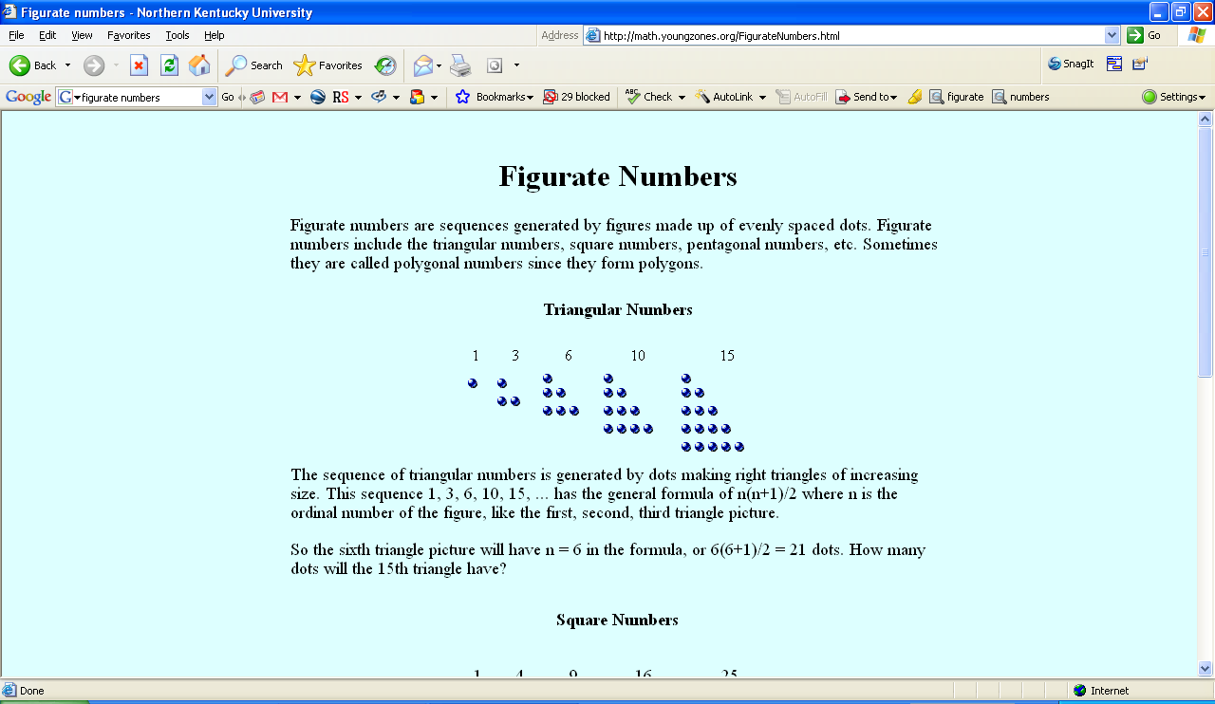
Square  numbers | 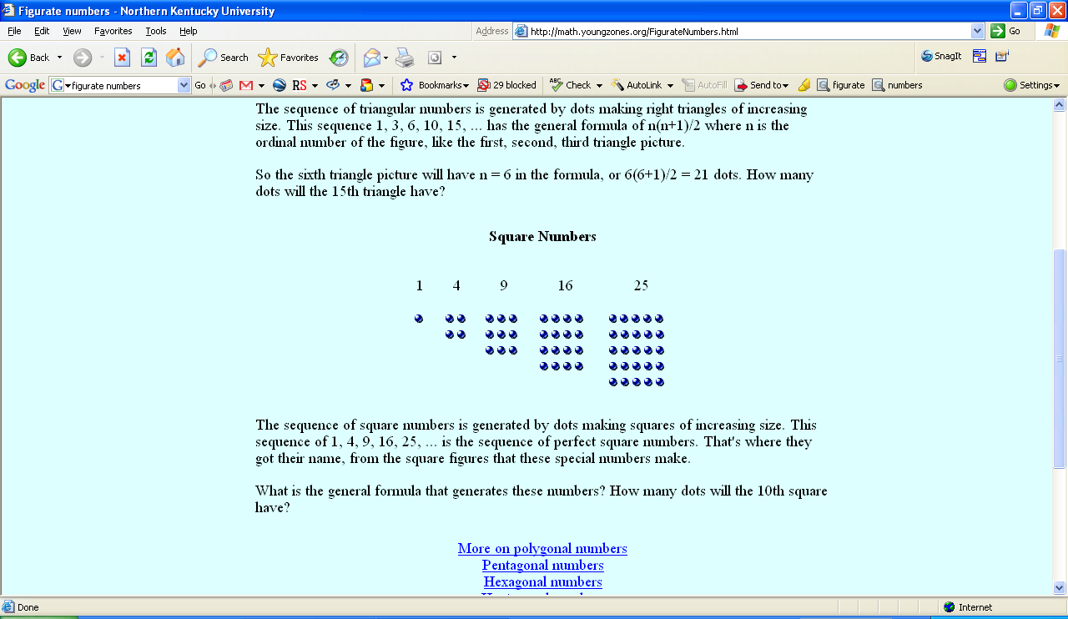
Pentagonal numbers | 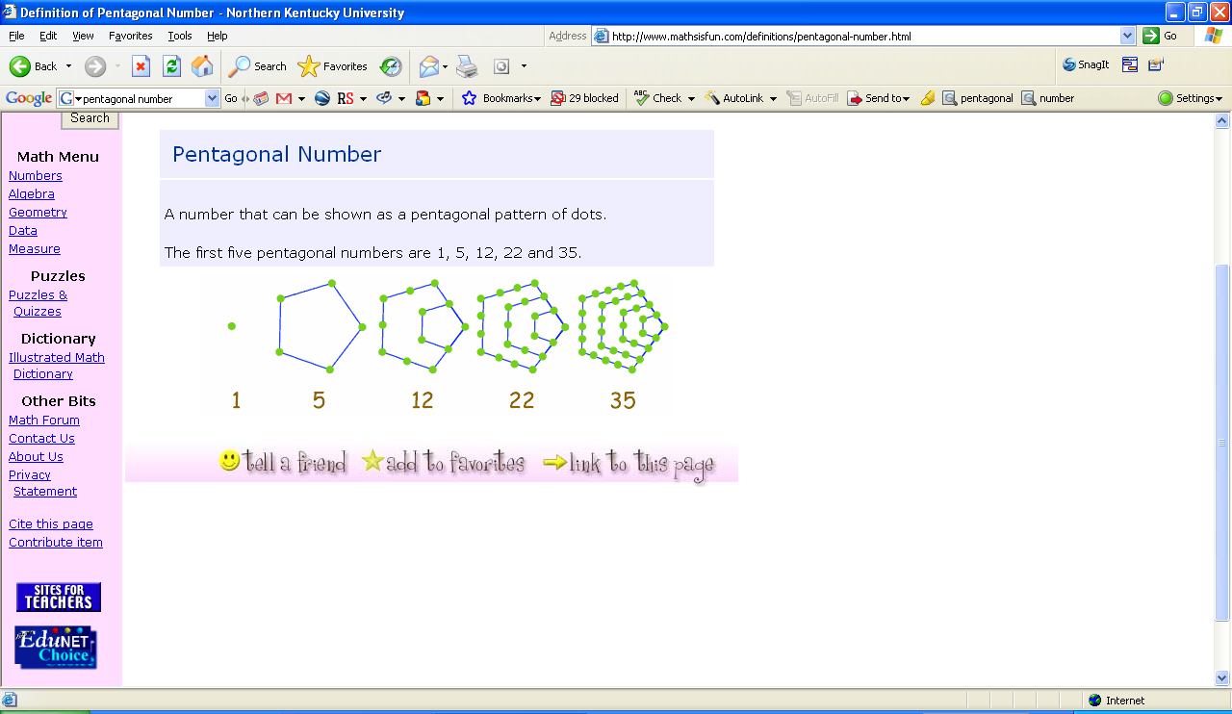
Hexagonal numbers | 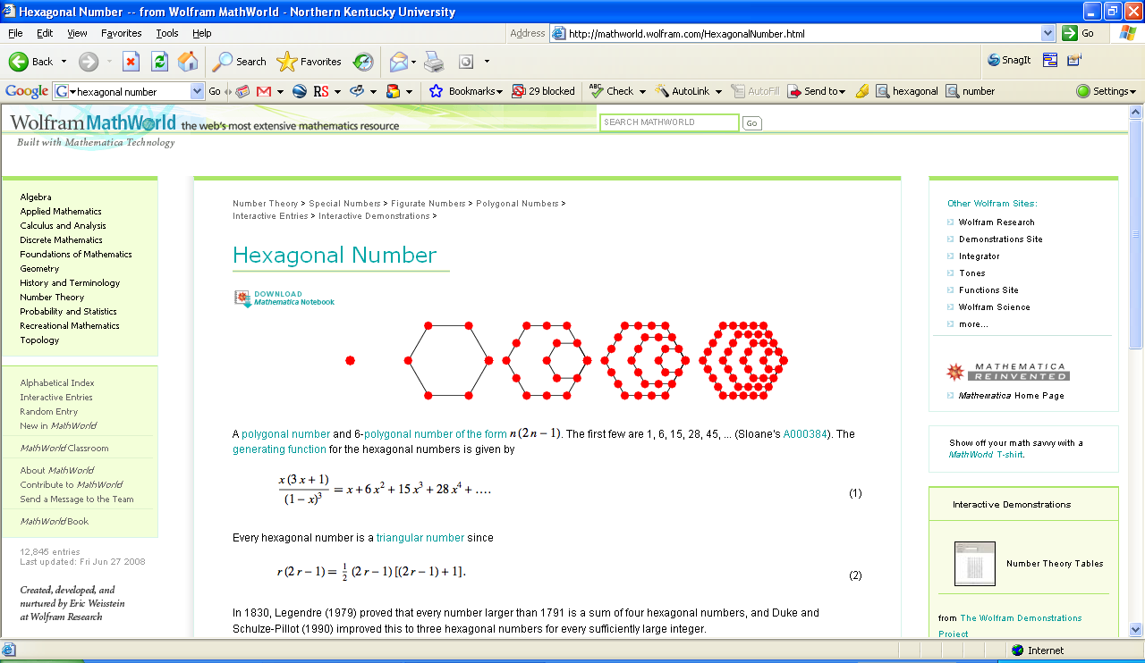

The goal of the state mathematics diagnostic intervention program is to expand the capacity of teachers to assess a child's current status and adjust instruction accordingly.

January—The Rekenrek/structuring to twenty

During Centra online meetings MITs will explore/use strategies and resources for advancing student skill in structuring to 20 using the Rekenrek, always keeping in mind that instruction must be targeted at each student’s readiness level. MITs will also discuss ways in which to facilitate students’ integration of the 3 aspects of number, including symbolic representation as well as quantitative reasoning and number words.
Resources –These suggestions are offered as flexible possibilities and should not be interpreted as required or exhaustive. Please select or supplement based on group need and availability of resources.

Andrews, Angela Giglio and Liesen, Diane Cushing. (2006). Reasoning with the Rekenrek. Jegro.

Blue Book→ (included with MR Specialist kit) Wright, Martland, Stafford. (2006). Early Numeracy; Assessment for teaching and intervention, 2nd Edition. Paul Chapman Publishing.
- Pages 64—67
- See various scenarios on pages 75—91
- Chapter 10: Linking the Assessment to Teaching

Bresser, Rusty and Holtzman, Caren. (2006). Minilessons for Math Practice, Grades K—2. Math Solutions Publications.
- Chapter 3: Breaking Numbers Apart
- Chapter 5: Coins

Fosnot, Catherine Twomey and Dolk, Marteen. (2001). Young Mathematicians at Work; Constructing Number Sense, Addition, and Subtraction. Heinemann.
- Chapter 3: Number Sense on the Horizon

Green Book→ (included with MR Specialist kit) Wright, Martland, Stafford, Stanger. (2007). Teaching Number; Advancing children’s skills and strategies, 2nd edition. Paul Chapman Publishing.
- Chapter 1: Advancing Children’s Strategies and Knowledge in Early Number
- Chapter 2: Individualized Teaching in Math Recovery (includes Guiding Principles of Teaching, Key Elements of Teaching, and Characteristics of Child Problem-Solving in Individualized Teaching)
- Chapter 8: Teaching the Counting-On Child

Purple Book→ (included with Add+Vantage Course 1 kit) Wright, Stanger, Stafford, Martland. (2006). Teaching Number in the Classroom with 4—8 Year Olds. Paul Chapman Publishing.
- Chapter 7: Structuring Numbers 1 to 20

White Book→ van den Heuvel-Panhuizen, Marja, editor (2001). Children Learn Mathematics, A Learning-Teaching Trajectory with Intermediate Attainment Targets for Calculation with Whole Numbers in Primary School. Freudenthal Institute, Utrecht University & National Institute for Curriculum Development.
- Pages 43-60: Grade 1 (and 2); Calculation up to twenty

Supplemental Unit→ Fosnot, Catherine Twomey (2007). Contexts in Learning: Investigating Number Sense, Addition, and Subtraction (K–3). The Double-Decker Bus: Early Addition and Subtraction. Heinemann.

++++++++++++++++++++++++++++++++++++++++++++++++++++++++++++++++++

Do math: Explore the different meanings of the subtrahend in a subtraction problem. Make up first grade word problems of the following types: a) The take-away interpretation for finding 15—12; b) The part-whole interpretation for 15—12; c) The comparison interpretation for 15—12. NCTQ

The goal of the state mathematics diagnostic intervention program is to expand the capacity of teachers to assess a child's current status and adjust instruction accordingly.
February—Tens and Ones
During Centra online meetings MITs will explore/use strategies and resources for advancing their concepts of tens and ones, always keeping in mind that instruction must be targeted at each student’s readiness level. MITs will also discuss ways in which to facilitate students’ integration of the 3 aspects of number, including symbolic representation as well as quantitative reasoning and number words.
Resources –These suggestions are offered as flexible possibilities and should not be interpreted as required or exhaustive. Please select or supplement based on group need and availability of resources.

Blue Book→ (included with MR Specialist kit) Wright, Martland, Stafford. (2006). Early Numeracy; Assessment for teaching and intervention, 2nd Edition. Paul Chapman Publishing.
- Pages 67—70
- see various scenarios on pages 75—91
- Chapter 6: Assessment Interview Schedule 1.2
- Chapter 10: Linking the Assessment to Teaching

Fosnot, Catherine Twomey and Dolk, Marteen. (2001). Young Mathematicians at Work; Constructing Number Sense, Addition, and Subtraction. Heinemann.
- Chapter 4: Place Value on the Horizon

Green Book→ (included with MR Specialist kit) Wright, Martland, Stafford, Stanger. (2007). Teaching Number; Advancing children’s skills and strategies, 2nd edition. Paul Chapman Publishing.
- Chapter 1: Advancing Children’s Strategies and Knowledge in Early Number
- Chapter 2: Individualized Teaching in Math Recovery (includes Guiding Principles of Teaching, Key Elements of Teaching, and Characteristics of Child Problem-Solving in Individualized Teaching)
- Chapter 9: Teaching the Facile Child

Purple Book→ (included with Add+Vantage Course 1 kit) Wright, Stanger, Stafford, Martland. (2006). Teaching Number in the Classroom with 4—8 Year Olds. Paul Chapman Publishing.
- Chapter 8: 2-digit Addition and Subtraction: Jump Strategies

Van de Walle, John A. and Lovin, Lou Ann. (2006). Teaching Student-Centered Mathematics: Grades K—3. Allyn & Bacon Publishing.
- Chapter 5: Base-ten concepts and place value

White Book→ van den Heuvel-Panhuizen, Marja, editor (2001). Children Learn Mathematics, A Learning-Teaching Trajectory with Intermediate Attainment Targets for Calculation with Whole Numbers in Primary School. Freudenthal Institute, Utrecht University & National Institute for Curriculum Development.
- Pages 61 to 87: Grade 2 (and 3); Calculation up to one hundred

Supplemental Unit→ Fosnot, Catherine Twomey (2007). Contexts in Learning: Investigating Number Sense, Addition, and Subtraction (K–3). Organizing and Collecting: The Number System. Heinemann.

++++++++++++++++++++++++++++++++++++++++++++++++++++++++++++++++++

Do math: Explore the base 10 structure of our number system and mental computation strategies by thinking about all the different ways students might jump from one number to another, ways to build numbers using sticks and bundles, and a mini-case study.
_________________
Model on an open number line all the ways, with a range of strategies, students might jump to find the distance between the following: a) 14 to 34; b) 14 to 33; c) 34 to 73; d) 52 to 22; e) 52 to 25; f) 52 to 27. Write additional strings of beginning and ending numerals, selected to scaffold particular mental strategies of jumping to benchmarks, jumps of tens and ones, jumping past the target and back (compensation), and constant differences (transference).
_________________
Find all the ways to use combinations of sticks (ones) and bundles (tens) to build the following numbers: 16, 26, 56, 126, 137, 142, 242. Choose and investigate more numbers. Find a generalization for the number of different ways to represent a numeral using sticks and bundles.
_________________
You are working individually with Bonny, and you ask her to count out 23 checkers,
which she does successfully. You then ask her to show you how many checkers are
represented by the 3 in 23, and she counts out 3 checkers. Then you ask her to show you how many checkers are represented by the 2 in 23, and she counts out 2 checkers. What problem is Bonny having here? (choose one)

a) Bonny doesn’t know how large 23 is.
b) Bonny thinks that 2 and 20 are the same.
c) Bonny doesn’t understand the meaning of the places in the numeral 23.
d) All of the above. MKT

The goal of the state mathematics diagnostic intervention program is to expand the capacity of teachers to assess a child's current status and adjust instruction accordingly.
March—Advanced addition and subtraction
During Centra online meetings MITs will explore/use strategies and resources for advancing student strategies for 2-digit addition and subtraction, always keeping in mind that instruction must be targeted at each student’s readiness level. MITs will also discuss ways in which to facilitate students’ integration of the 3 aspects of number, including symbolic representation as well as quantitative reasoning and number words.
Resources –These suggestions are offered as flexible possibilities and should not be interpreted as required or exhaustive. Please select or supplement based on group need and availability of resources.

Blue Book→ (included with MR Specialist kit) Wright, Martland, Stafford. (2006). Early Numeracy; Assessment for teaching and intervention, 2nd Edition. Paul Chapman Publishing.
- Pages 70—72
- See scenarios of various stages on pages 75—91
- Chapter 10: Linking the Assessment to Teaching

Bresser, Rusty and Holtzman, Caren. (2006). Minilessons for Math Practice, Grades K—2. Math Solutions Publications.
- Chapter 10: Finding Friendly Numbers
- Chapter 12: Greater Than, Less Than, Is Equal To

Fosnot, Catherine Twomey and Dolk, Marteen. (2001). Young Mathematicians at Work; Constructing Number Sense, Addition, and Subtraction. Heinemann.
- Chapter 5: Developing Mathematical Models
- Chapter 6: Addition and Subtraction Facts on the Horizon
- Chapter 7: Algorithms Versus Number Sense

Green Book→ (included with MR Specialist kit) Wright, Martland, Stafford, Stanger. (2007). Teaching Number; Advancing children’s skills and strategies, 2nd edition. Paul Chapman Publishing.
- Chapter 1: Advancing Children’s Strategies and Knowledge in Early Number
- Chapter 2: Individualized Teaching in Math Recovery (includes Guiding Principles of Teaching, Key Elements of Teaching, and Characteristics of Child Problem-Solving in Individualized Teaching)

Purple Book→ (included with Add+Vantage Course 1 kit) Wright, Stanger, Stafford, Martland. (2006). Teaching Number in the Classroom with 4—8 Year Olds. Paul Chapman Publishing.
- Chapter 9: 2-digit Addition and Subtraction: Split Strategies

Van de Walle, John A. and Lovin, Lou Ann. (2006). Teaching Student-Centered Mathematics: Grades K—3. Allyn & Bacon Publishing.
- Chapter 6: Strategies for whole number computation.

Supplemental Unit→ Fosnot, Catherine Twomey (2007). Contexts in Learning: Investigating Number Sense, Addition, and Subtraction (K–3). Measuring for the Art Show. Heinemann.

Supplemental Unit→ Fosnot, Catherine Twomey (2007). Contexts in Learning: Investigating Number Sense, Addition, and Subtraction (K–3). Trades, Jumps and Stops. Heinemann.

++++++++++++++++++++++++++++++++++++++++++++++++++++++++++++

Do math: Explore the early algebraic reasoning that occurs when NUMERATE students have achieved fluency and use flexible mental math strategies. Identify the mental computation strategies and their corresponding algebraic properties.
a) To find the sum of 29 + 17, Miranda did 30 + 17 = 47 and 47 -1 = 46.
b) To find the difference of 47 – 19, Danny did 48 – 20 = 28.
c) To find the sum of 5 + 28, Julia did 28 + 2 = 30 and 30 + 3 = 33.
d) To find the sum of 58 + 23, Bill did 50 + 20 = 70, 8 + 3 = 11 and 70 + 11 = 81.
e) To find the sum of 36 + 58, Tomica did 58 + 30 = 88, 88 + 2 = 90, and 90 + 4 = 94.
f) To find the sum of 18 + 7, Kirsten did 15 + 5 = 20 and 3 + 2 = 5, so 20 + 5 = 25.
g) To find the difference of 92 – 48, Marcus did 92 – 40 = 52, 52 – 2 = 50, and 50 – 6 = 44.
h) To find the difference of 73 – 22, Laquisha did 73 – 23 = 50 and 50 + 1 = 51.
GABBARD
________________________
- The following word problem is given to a student: Phillip has 14 bags of lollipops. Each bag has 23 lollipops in it. How many lollipops does Phillip have?
Laura solves the problem as follows:
10 x 20 = 200
10 x 3 = 30
4 x 20 = 80
4 x 3 = 12

80 + 20 → 100 + 200 → 300 + 10 → 310 + 10 → 320 + 2 → 322
Use Laura’s strategy to solve 126 x 9. KENT
________________________
- Laura’s strategy in #9 can be represented symbolically by the following set of steps. On the line next to each set of steps, choose from the following to identify each step: commutative property, place value, associative property, distributive property, number fact.
14 x 23 = (10 + 4) x (20 + 3) ___________________

= 10 x (20 + 3) + 4 x (20 +3) ___________________

= (10 x 20 + 10 x 3) + (4 x 20 + 4 x 3) ___________________

= 200 + 30 + 80 + 12 ___________________

= 30 + 80 + 200 + 12 ___________________

= 10 + (20 + 80) + 200 + 12 ___________________

= 10 + (100 + 200) + 12 ___________________

= 10 + 300 + 12 ___________________

= 310 + 10 + 2 ___________________

= 320 + 2 ___________________

= 322 ___________________
KENT

The goal of the state mathematics diagnostic intervention program is to expand the capacity of teachers to assess a child's current status and adjust instruction accordingly.
April—Early Multiplication and Division
During Centra online meetings MITs will explore/use strategies and resources for advancing student strategies in early multiplication and division, always keeping in mind that instruction must be targeted at each student’s readiness level. MITs will also discuss ways in which to facilitate students’ integration of the 3 aspects of number, including symbolic representation as well as quantitative reasoning and number words.
Resources –These suggestions are offered as flexible possibilities and should not be interpreted as required or exhaustive. Please select or supplement based on group need and availability of resources.

Blue Book→ (included with MR Specialist kit) Wright, Martland, Stafford. (2006). Early Numeracy; Assessment for teaching and intervention, 2nd Edition. Paul Chapman Publishing.
- See scenarios of various stages on pages 75—91
- Chapter 8: Assessment Interview Schedules 3.1 and 3.2
- Chapter 10: Linking the Assessment to Teaching

Bresser, Rusty and Holtzman, Caren. (2006). Minilessons for Math Practice, Grades K—2. Math Solutions Publications.
- Chapter 14: Measuring Area with Color Tiles

Green Book→ (included with MR Specialist kit) Wright, Martland, Stafford, Stanger. (2007). Teaching Number; Advancing children’s skills and strategies, 2nd edition. Paul Chapman Publishing.
- Chapter 1: Advancing Children’s Strategies and Knowledge in Early Number
- Chapter 2: Individualized Teaching in Math Recovery (includes Guiding Principles of Teaching, Key Elements of Teaching, and Characteristics of Child Problem-Solving in Individualized Teaching)

Purple Book→ (included with Add+Vantage Course 1 kit) Wright, Stanger, Stafford, Martland. (2006). Teaching Number in the Classroom with 4—8 Year Olds. Paul Chapman Publishing.
- Chapter 10: Early Multiplication and Division

++++++++++++++++++++++++++++++++++++++++++++++++++++++++++++++++++

Do math: Explore partitive (sharing) and measurement (grouping) models for division, divisibility rules, and a creative algorithm.
________________
Make up two word problems for which division is required, both involving some type of fruit, according to each of the meanings specified: a) Express the partitive (sharing) meaning of division for 50/10; b) Express the measurement (grouping) meaning of division for 50/10. NCTQ
________________
Ms. Harris was working with her class on divisibility rules. She told her class that a
number is divisible by 4 if and only if the last two digits of the number are divisible by 4.
One of her students asked her why the rule for 4 worked. She asked the other students if
they could come up with a reason, and several possible reasons were proposed. Which of the following statements comes closest to explaining the reason for the divisibility rule for 4? (choose one)
a) Four is an even number, and odd numbers are not divisible by even numbers.
b) The number 100 is divisible by 4 (and also 1000, 10,000, etc.).
c) Every other even number is divisible by 4, for example, 24 and 28 but not 26.
d) It only works when the sum of the last two digits is an even number. MKT
_________________
As Mr. Callahan was reviewing his students’ work from the day’s lesson on
multiplication, he noticed that Todd had invented an algorithm that was different from the
one taught in class. Todd’s work looked like this:
983
x 6
488
+5410
5898

What is Todd doing here? (choose one)
a) Todd is regrouping ("carrying") tens and ones, but his work does not record the
regrouping.
b) Todd is using the traditional multiplication algorithm but working from left to right.
c) Todd has developed a method for keeping track of place value in the answer that is
different from the conventional algorithm.
d) Todd is not doing anything systematic. He just got lucky – what he has done here will not work in most cases. MKT

