
This document contains spinner bases for use with a clear spinner. Pages 2—9 contain blank bases onto which you can add the desired numerals, either from the numeral bank or by hand. Pages 10—17 contain bases with numerals that can easily be used as is or modified.
Numeral Bank
Select and drag (or copy/paste) these numerals into the spinner bases below.
1
0
3
2
6
5
4
8
7
9

10
11
18
17
16
15
14
13
12
19
70
60
50
40
20
30
90
80
71
94
83
??
66
57
26
42
38
Insert your own→
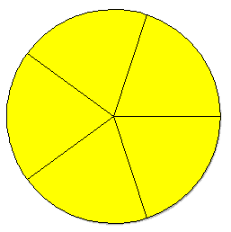

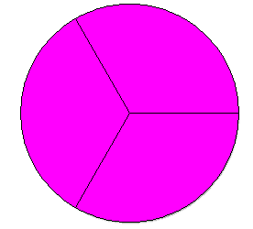

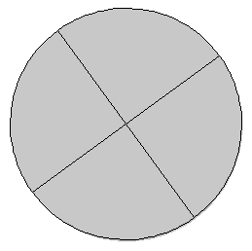

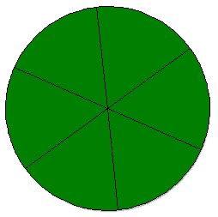

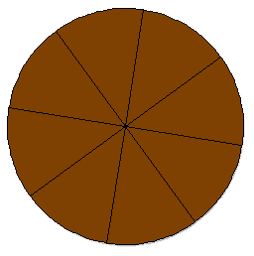

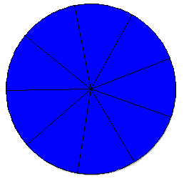

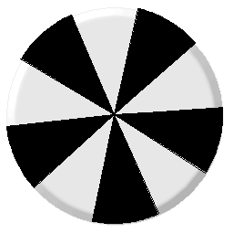

??
??
??
??
??
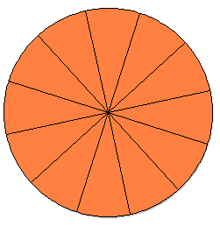

5
9
6
7
8

1
3
2

9
8
7
10

30
10
20
30
20
10

13
14
15
11
18
16
17
12

52
33
42
51
61
72
22
81
91

-2
+0
-1
+2
+1
+3
+3
-3
+1
+2

9
39
18
49
38
28
69
58
39
48
8
29

