Coin Models for Early Numeracy

Students who have progressed only to the unitary/perceptual thinking stage are not yet able to understand that silver coins are composite units representing several pennies. The models below were developed to provide different levels of support for students who need further experience with alternate representations of each composite coin value.

The most support is provided by giving students the models below showing all the pennies. The next level of support would be to give students the model with place holders only, but no pennies, and the third level of support provides an area model to represent the value in proportion to other coins. Another way to modify the level of support is to keep the composite coin visible alongside the pennies or you may fold it back or affix it to a cover that can be flipped up. By putting the composite coin on the back or on a flap, you can encourage students to think in a figurative way to internalize the quantities that are represented, but hidden.

Another tip, suggested by Linda Jewell, for developing proficiency with counting coins is to make sure that students can count forward and backward by fives and tens off the multiples. For example, students must be able to count by fives, such as 6, 11, 16, 21, 26, … and 7, 12, 17, 22, 27, 32, …, etc. as well as counting 5, 10, 15, 20, 25, …. Likewise students must be able to count by 10s, such as 13, 23, 33, 43, 53, 63, etc. Students who learn the standard counting by multiples (5, 10, 15, 20, 25, … and 10, 20, 30, 40, 50, …) may be just reciting a poem rather than thinking mathematically. Counting off the multiples by 5 and 10, both forward and backward, also leads to proficiency with computation and place value.

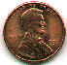

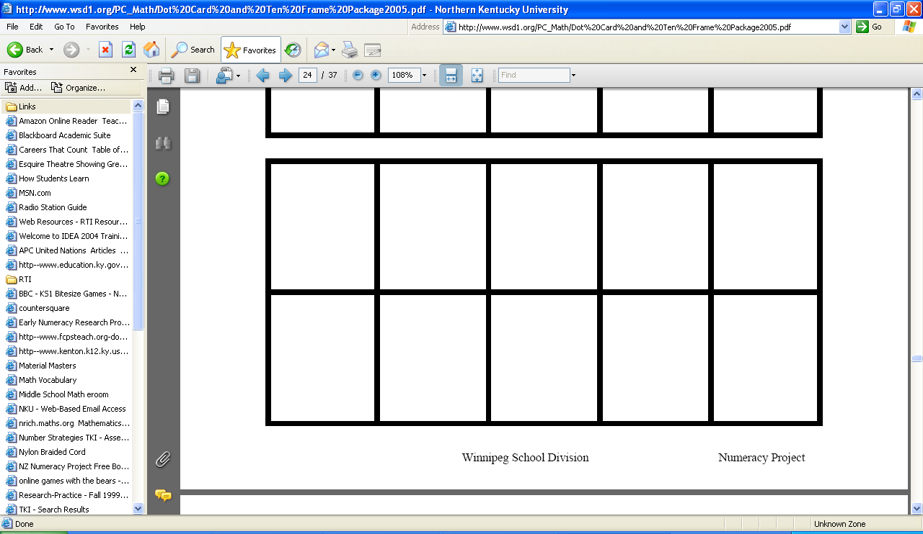



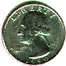

Resources for Developing Composite Thinking

Kolson, K., Mole, S., Silva, M. (2005-2006) Dot Card and Ten Frame Activities, Winnipeg School Division http://www.wsd1.org/PC_Math/Dot%20Card%20and%20Ten%20Frame%20Package2005.pdf

Printable Dot Card Masters from Van deWalle: http://wps.ablongman.com/ab_vandewalle_math_5/0,7959,796756-,00.html

Wright, Stanger, Stafford, and Martland. (2006). Teaching Number in the Classroom
with 4—8 year—olds. Paul Chapman Publishing.)

Wright, Martland, Stafford, and Stanger. (2005). Teaching Number; Advancing children’s skills and strategies. Paul Chapman Publishing Ltd.

Wright, R. J., Martland, J., & Stafford, A. K. (2000). Early numeracy: Assessment for teaching and intervention. Thousand Oaks, CA: Sage Publications, Inc.

Also, see the Kentucky Center for Mathematics website for additional resources:
http://kentuckymathematics.org

