EXCEL and Spinners
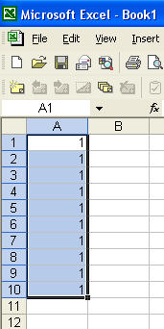

- Open up a new EXCEL book

- For a 10 section spinner, place the same number in cells A1 through A10.

- Highlight A1 through A10.

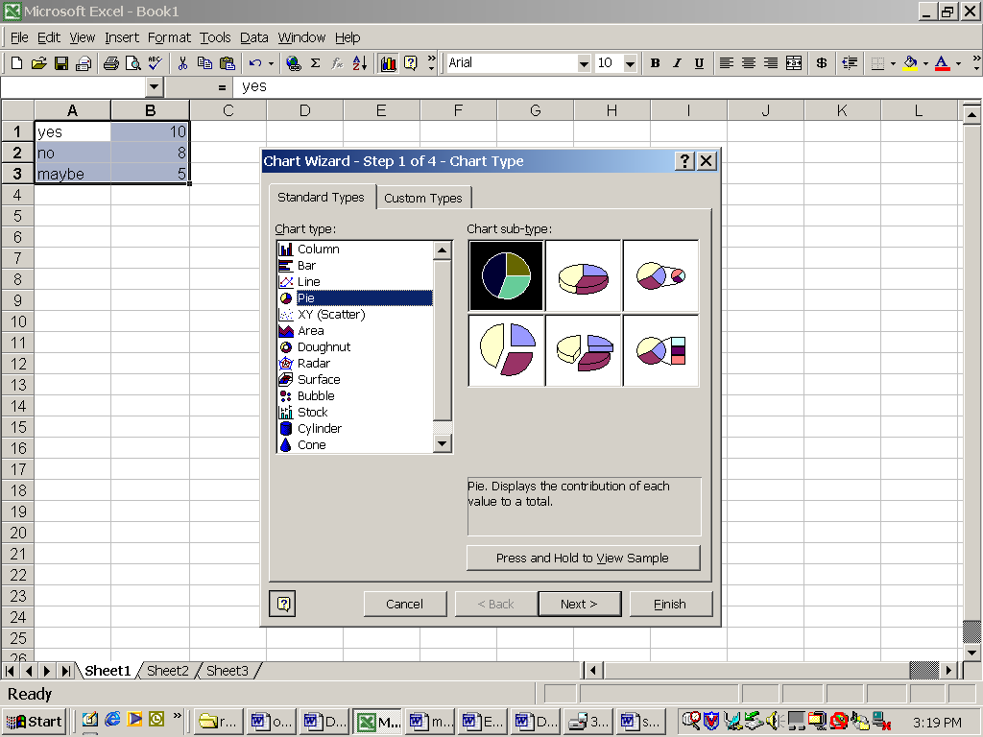
- Click on the Chart Wizard.

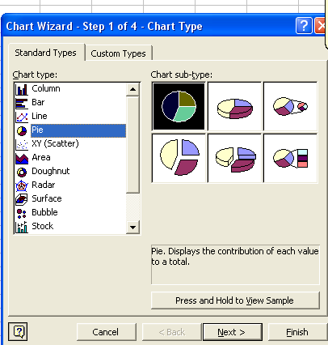
- Choose Pie Graph

- Choose the first option for the pie graphs.

- Click on Finish

- Your graph should look like this.

- To delete the legend, click on it to select it, then right-click on the legend and choose Clear.
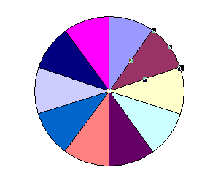

- Click on one section of the pie to select it, then right-click and choose Format Data Point to select the color. Do this for each section of the pie.

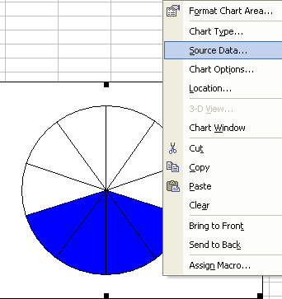
- To change the number of sections for your spinner, right-click on the white chart area and choose Source Data.

- Change the Data Range from =Sheet1!$A$1:$A$10 to =Sheet1!$A$1:$A$5 for a 5 section spinner.

