START |  | CHANCE |  |  |  | CHANCE
 |  | Math Race |  |  |  |  |  |  | CHANCE
CHANCE | CHANCE |  |  |  | CHANCE
 | 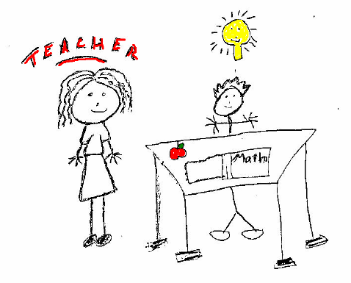 |  |  |  |  |  |  |  | CHANCE
 |  | FINISH |  |  | CHANCE | CHANCE |  | 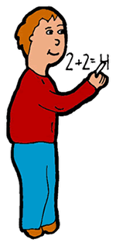
CHANCE
 | CHANCE |  |  | CHANCE |  |  |  | CHANCE

