Finger Math for Sixes through Tens

Place both hands palm down in front of you.

Starting with each thumb, number your thumb and fingers 6, 7, 8, 9, 10
8
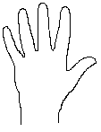
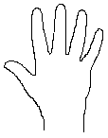
7
8
9
10
7
9
10
6
6

Example: 8 x 9

Fold down the fingers 6, 7, 8 on one hand and fingers 6, 7, 8, 9 on the other hand.
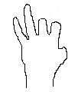
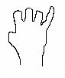

All the fingers that are folded down get multiplied by ten
(7 x 10). The fingers that are not folded are multiplied together (2 x 1). The product of 8 x 9 is 7 x 10 + 2 x 1.

